

**SOFTWARE ENGINEERING**

***MEDICAL CLINIC***

AUTHORS:

Iñaki Seco ; Sefa Kurtoglu

PROFESSORS:

Tadeusz Dyduch ; Małgorzata Żabińska-Rakoczy

09/11/2017

**1. Project description** 2

1.1 Area and subject of modeling 2

1.1.1 Problem domain 2

1.2.1 Description of organization structure 2

1.2.2 Activity areas 3

1.3 Activity areas’ description 3

1.3.1 Posts description 3

1.3.2 Business procedures description 3

1.4 Verified system’s responsibilities 4

1.5 Short problems 4

1.6 Goals: 4

1.6.1 Product’s aims 4

1.6.2 Design aims 4

## 1. Project description

### 1.1 Area and subject of modeling

##### 1.1.1 Problem domain

The company is a medical organization composed of many different employees and created to reach every person that needs medical assistance, so that is the kind of people that are going to be interested on the project.

The software is going to be used in a medical clinic, helping both employees and clients, so for example the patients will be able to ask for a meeting with the doctor when they need medical assistance and doctors will send messages and prescriptions back to the patients.

**1.2 Modeling area**

##### 1.2.1 Description of organization structure

Thanks to our modelling project, the organization of any medical clinic will be extremely easy to administrate. In these systems are going to take part not only the doctors and nurses but also the patients and providers of each office. The

The employees will be able to modified things such important like medical records of theirs patients or diagnostics from the appointments, as well as others less vital stuffs like, for example, holidays and vacations. In addition to that, patients will have the choice to make online appointments in a really simple way.

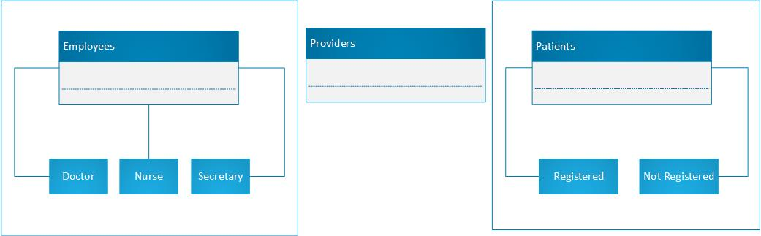

##### 

##### 1.2.2 Activity areas

Each clinic will content the following areas separately:

* Administrative area
* Medical area
* Ordering area
* Human resources

### 1.3 Activity areas’ description

##### 1.3.1 Posts description

* Administrative area:

This area concerns everything what has to do with calendars, payments and identities or information about every individual interact with the clinic. Legal documentations and signed contracts from each person who has work or gain from those services.

* Medical area

The medical records and analyzes belongs to this area, as well as treatments followed by the patients and doctors. This information is quite sensitive due to its delicacy, so it will be specially good protected.

* Ordering area

Here we will include purchases and sales of different products which are necessary for the company. They are going to be mainly medicines and hygiene items for the maintenance of the office and services.

* Human resources

This area will be dedicated to manage the environment between the employees, additionally, they handle all new employees and other kind of internal problems.

##### 1.3.2 Business procedures description

* Administrative area:

The employees in this area participate in a lot of business deals, they have to manage and store every contract done with a client, management of documents and information of the doctors, etc.

* Medical area

There have to be a very good and special business deal on this area with the security of data enterprises, cause here is where the medical data is managed.

* Ordering area

This area is working directly with the providers, making deals and orders every week to have the necessary materials and medicaments for the clinic. Once they have closed a deal they must send the pertinent documents to the administrative area.

* Human resources

Human resources negotiate with the employees their contracts and new salaries, and also are the ones in charge of the new hires and layoffs.

### 1.4 Verified system’s responsibilities

The system must guarantee a fast and good communication between the company and the clients, because patients must need a medical response quickly in case they have a serious health problem.

Also, it must store the medical data of the employees and of the registered clients, but with a very good security system to protect the people personal and medical information and prevent legal problems.

### 1.5 Short problems

One of the biggest problems the system will have to handle with is the unpredictable success of itself, so we will have to work and improve the system in case we have a lot of demand. For example, if we have a lot of registered clients we must store a huge amount of data and also have a better security system.

Another problem could be the fact that older people are less used to using new technologies, so we should implement in a way that everyone find it easy. Also, we could make it more international offering a few options for the language of the system and the communication with the employees.

### 1.6 Goals:

##### 1.6.1 Product’s aims

This product aims are to improve communication between hospital and patients, it will help to direct referrals to other hospital. On the other hand, the product is going to be beneficial for the shipment of medicines and materials.

##### 1.6.2 Design aims

This application is calculated specially to help older people, the design includes a small messaging application so these people will be able to communicate immediately without the needed of going to the hospital.